Shallow Neural Network – 1 layer

# Neural network representation

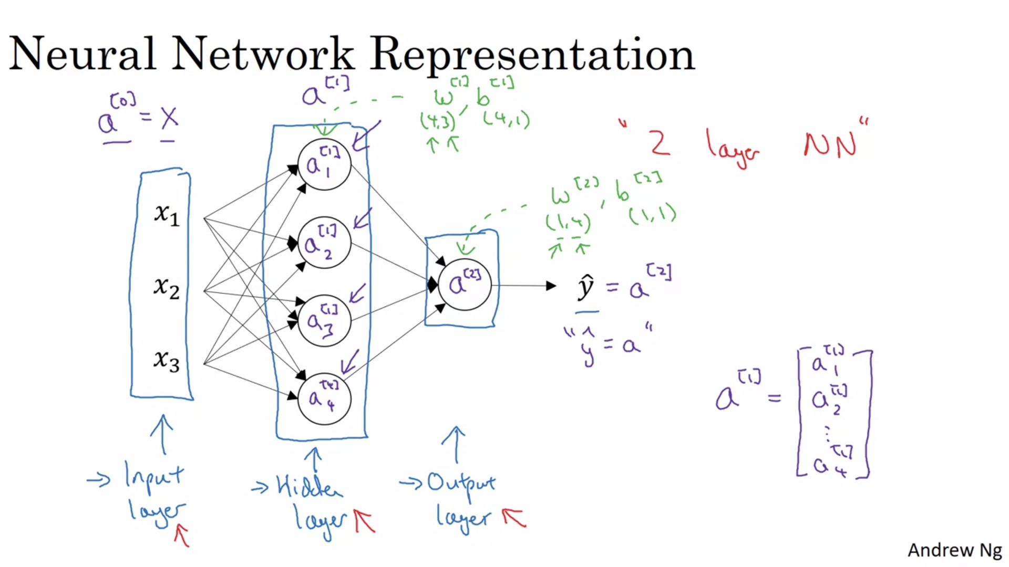

a[0], a[1] and a[2] are known as activations for corresponding layers.

Also, the above one NN is mostly called 2-layer NN since while counting the layers, input layer is not counted.

A[1]2 – superscript value is for the layer number and subscript value is the position of node in that layer.

# Computing a neural network’s output

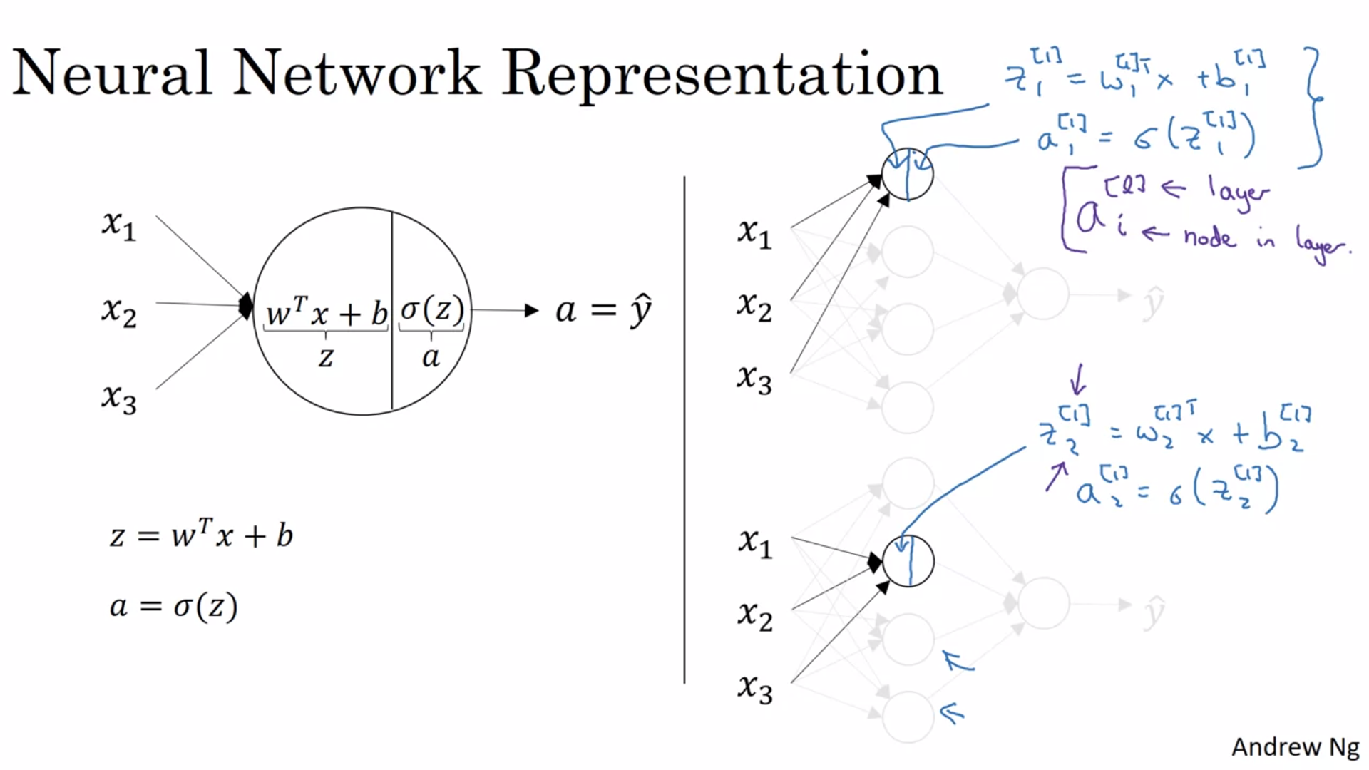

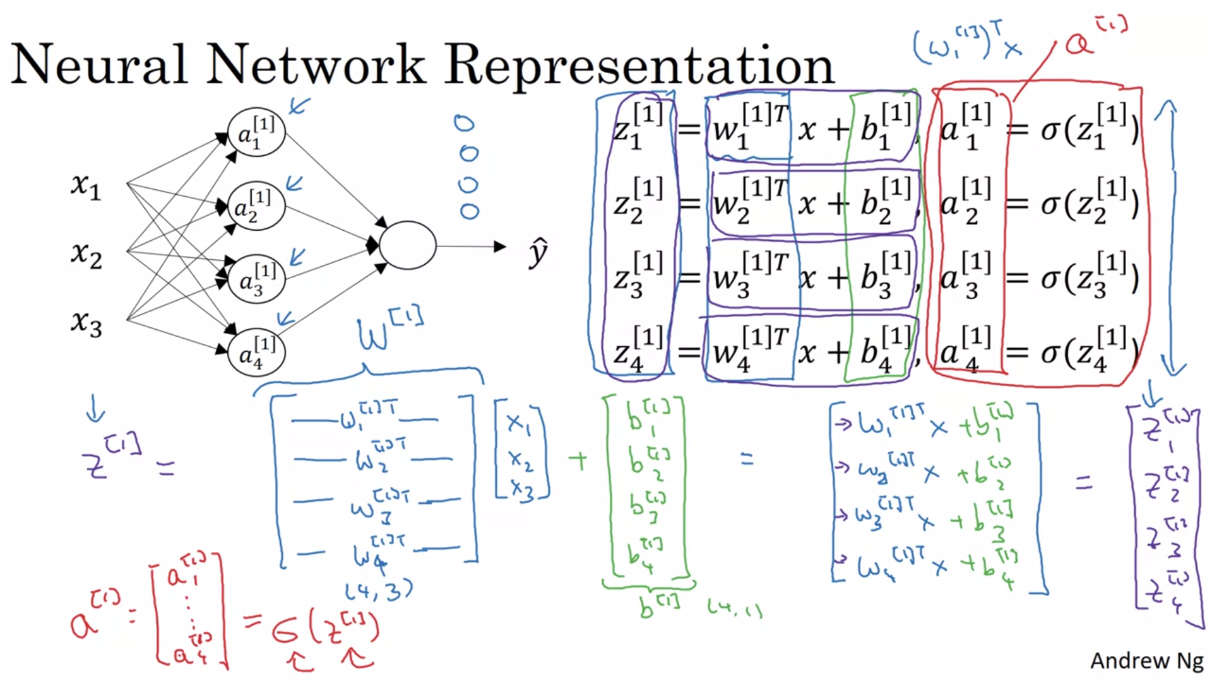

Here parameters are stacked vertically which can be seen as corresponding to nodes in the given layer.

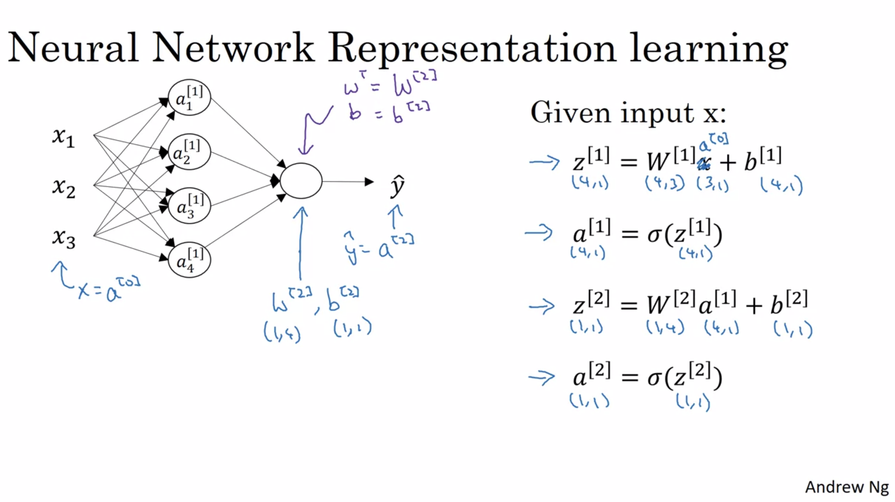

The four equations mentioned in above image represent output of a NN for a single example. We will now see equations taking all examples in consideration.

# Vectorizing across multiple examples

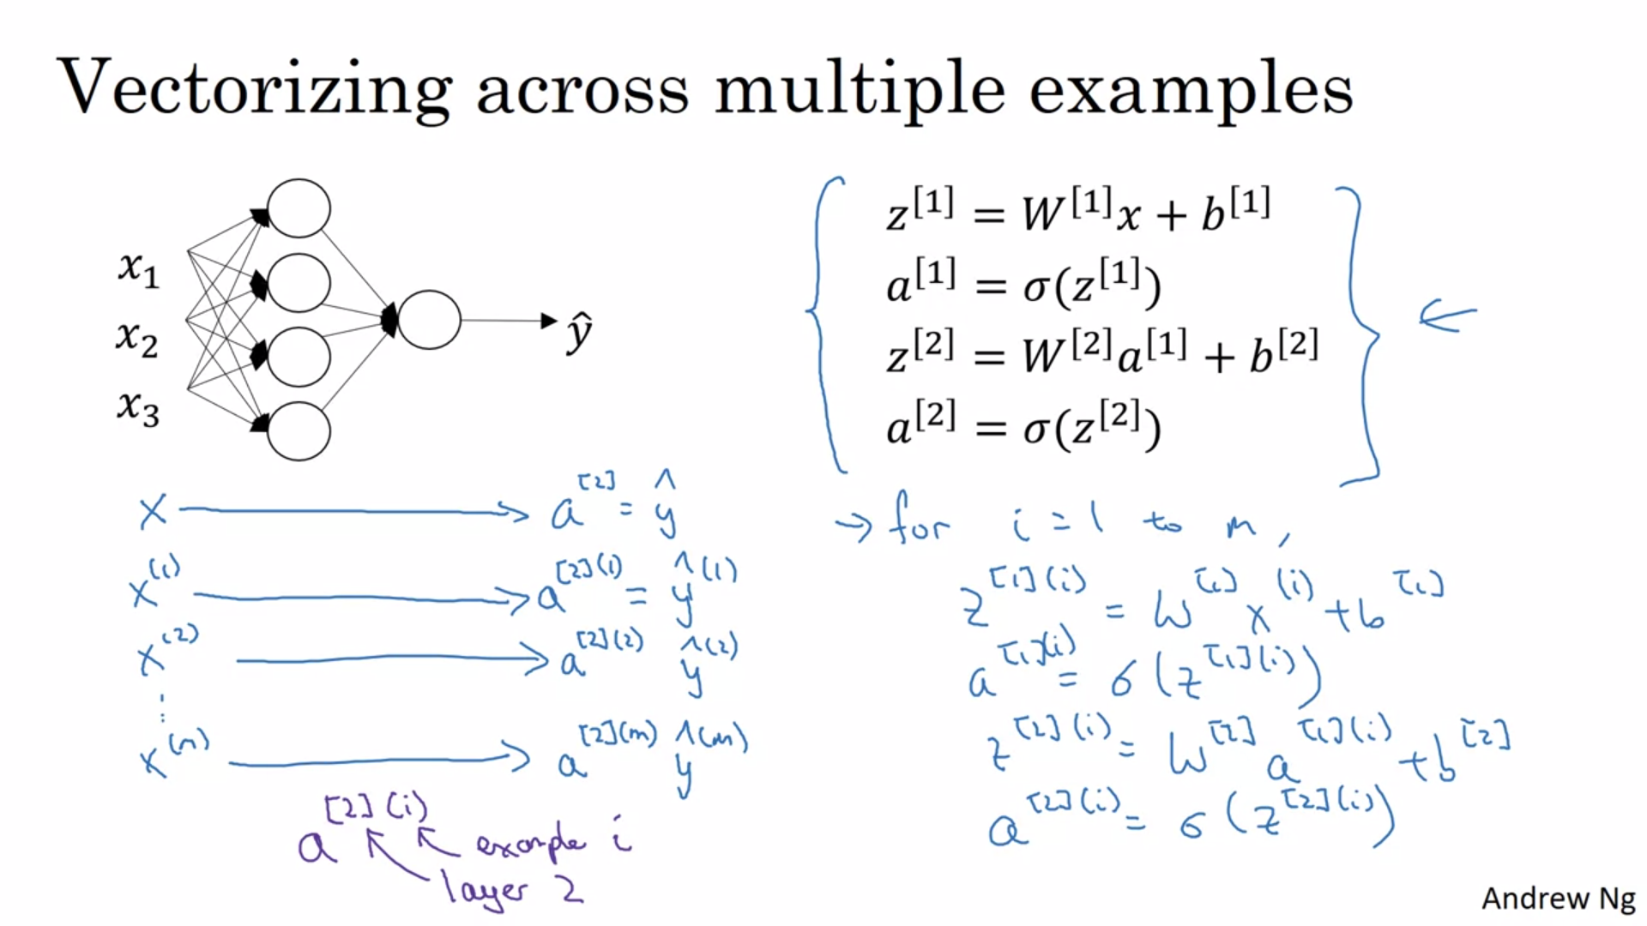

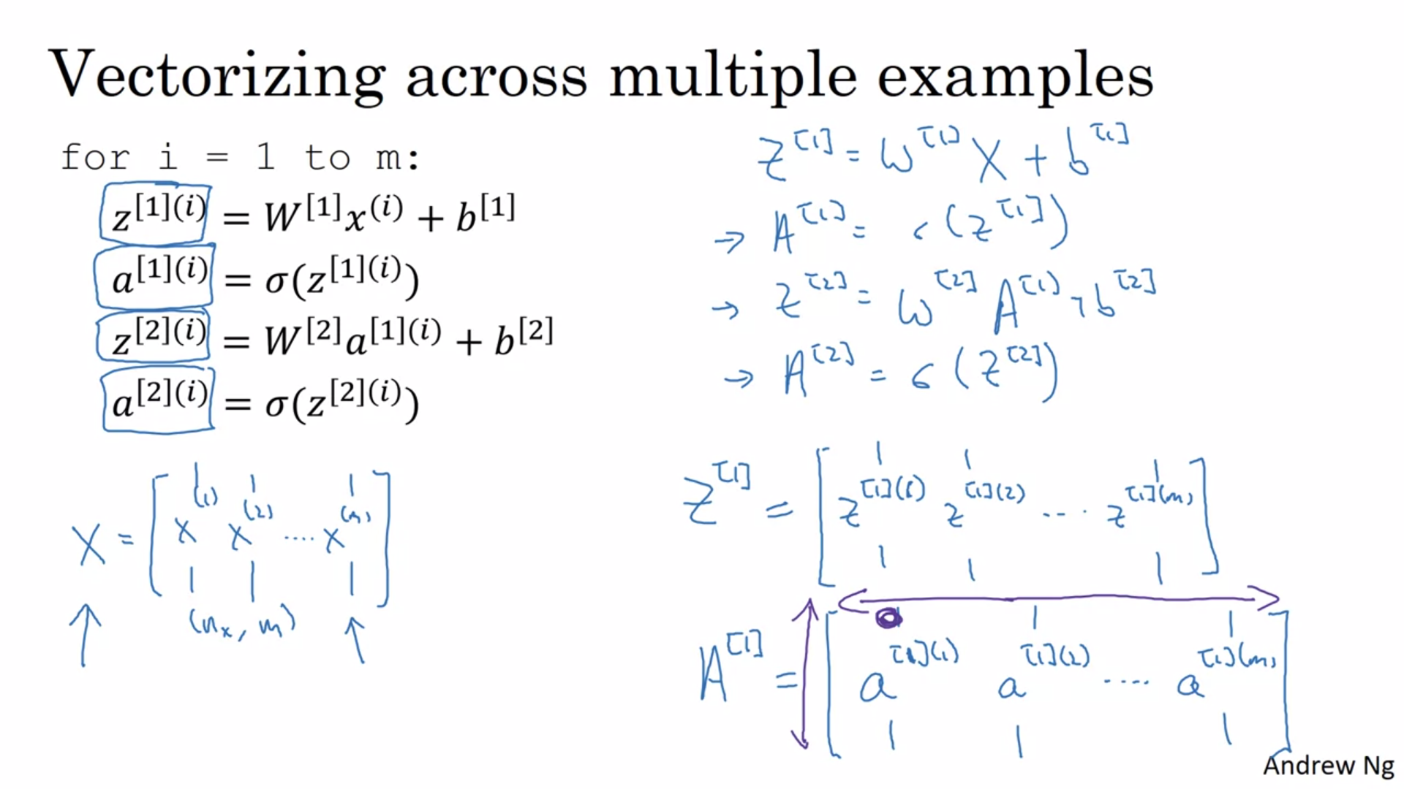

# Explanation for Vectorized Implementation

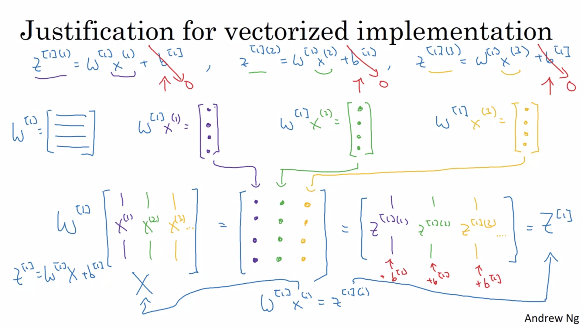

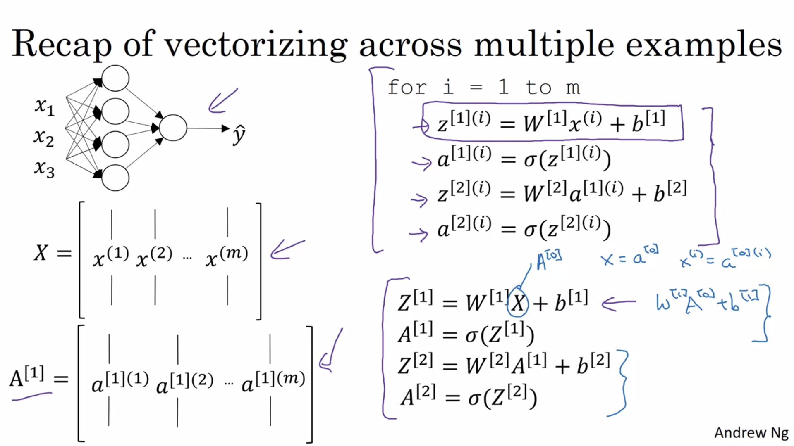

# Activation functions

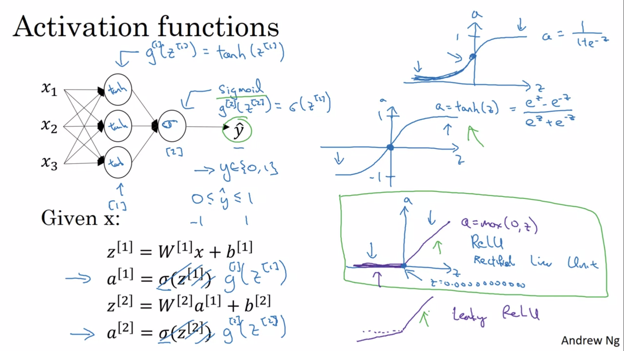

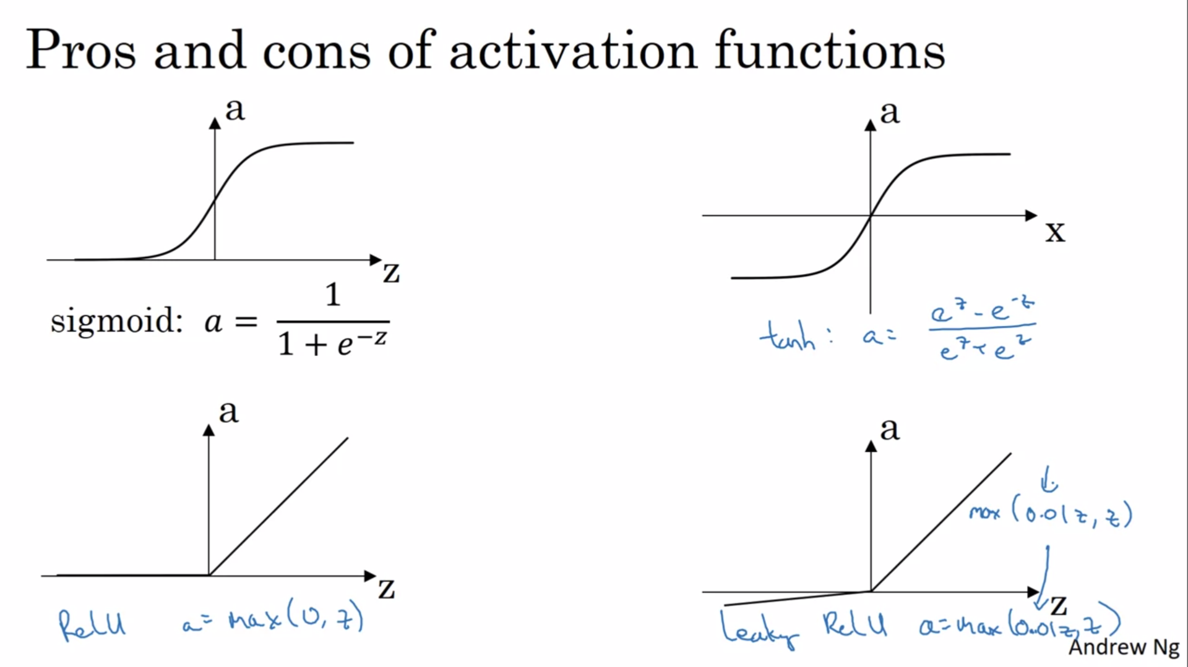

# Why do you need non-linear activation functions?

# Derivatives of activation functions

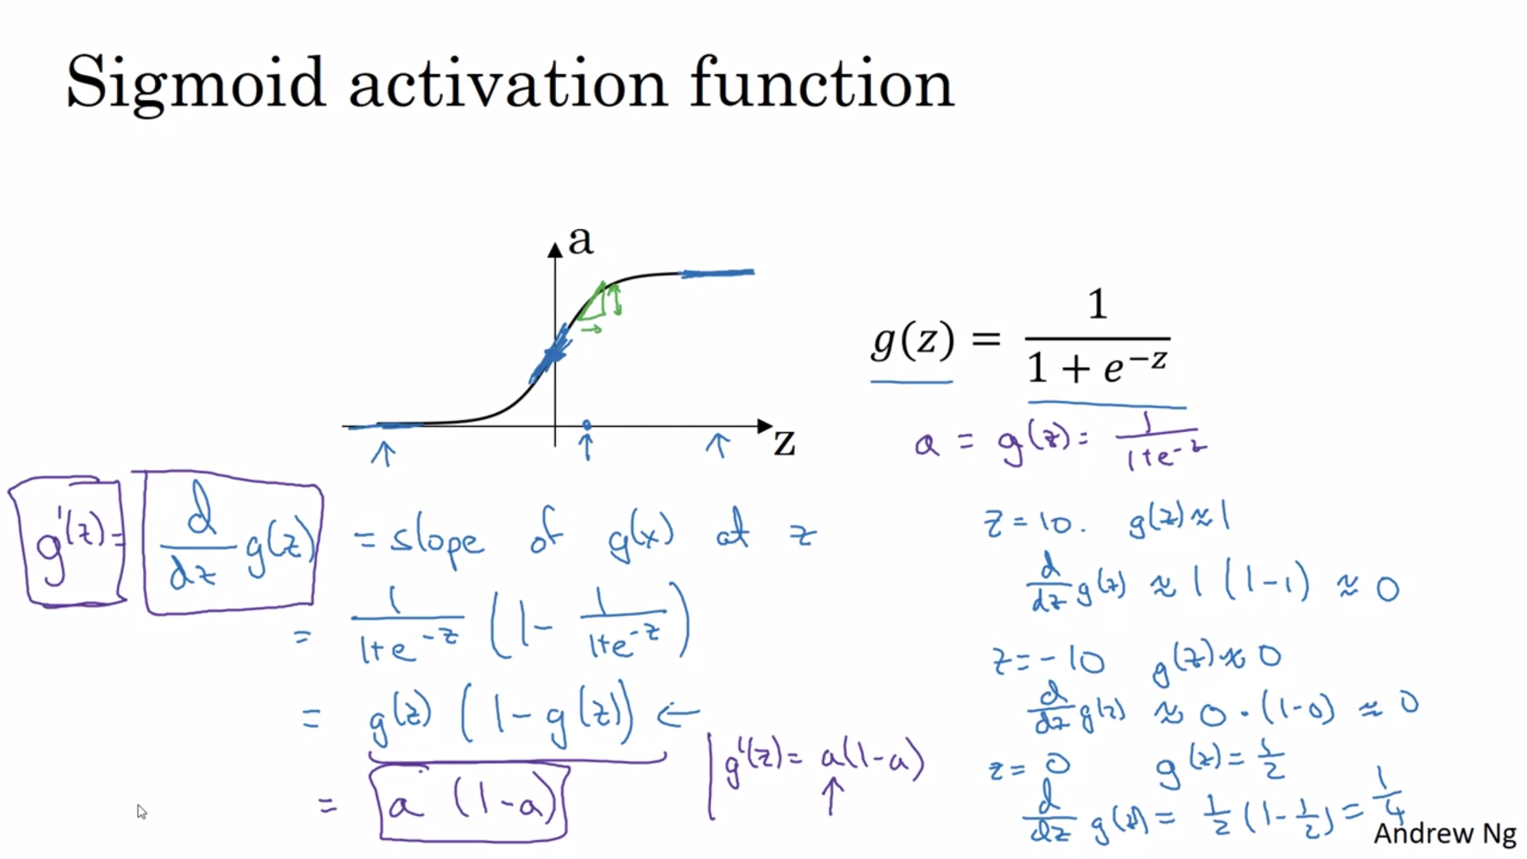

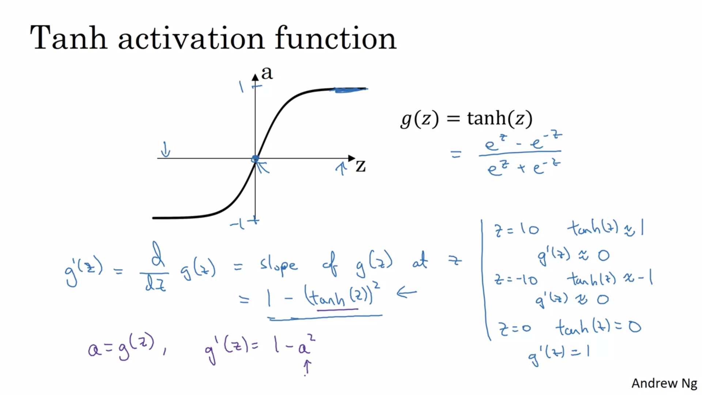

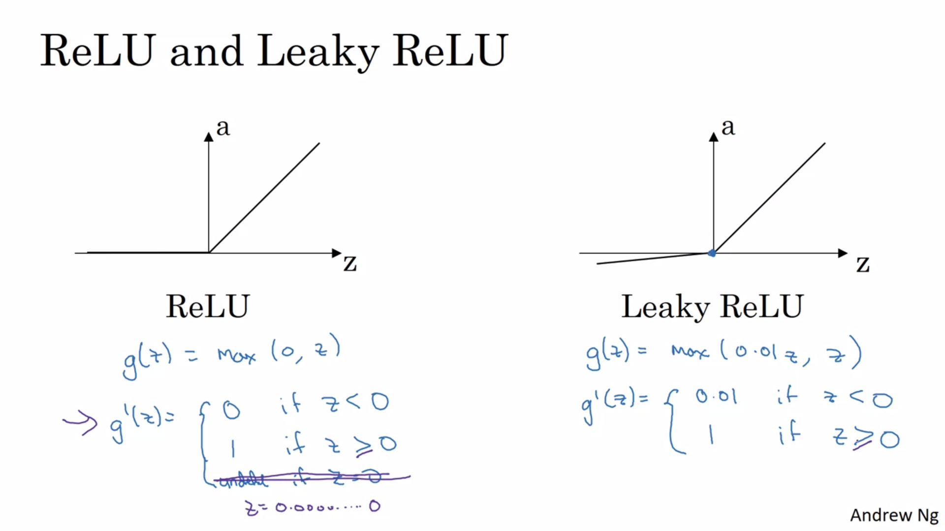

# Gradient descent for Neural Networks

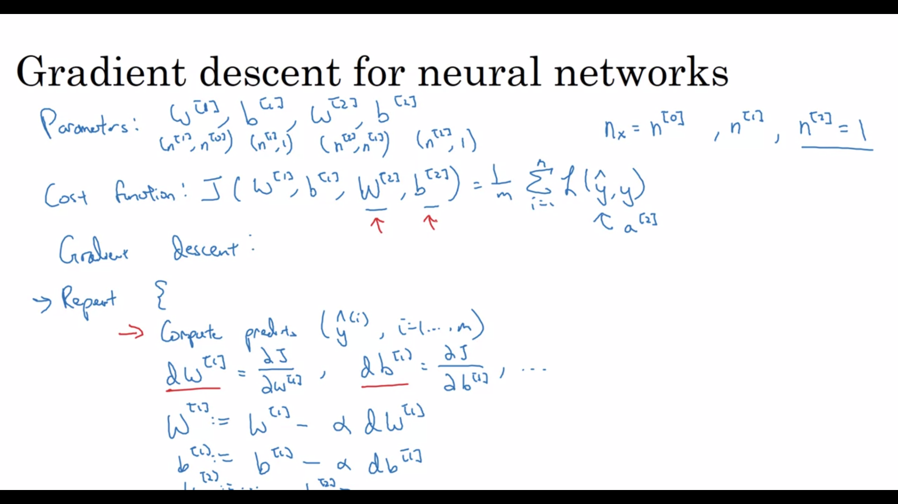

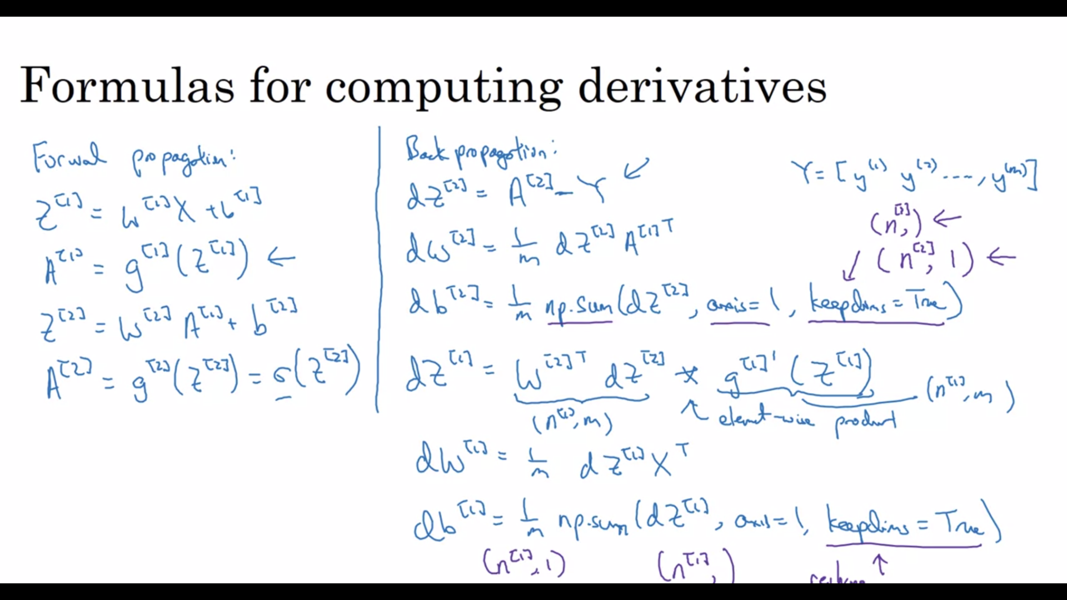

# Backpropagation intuition

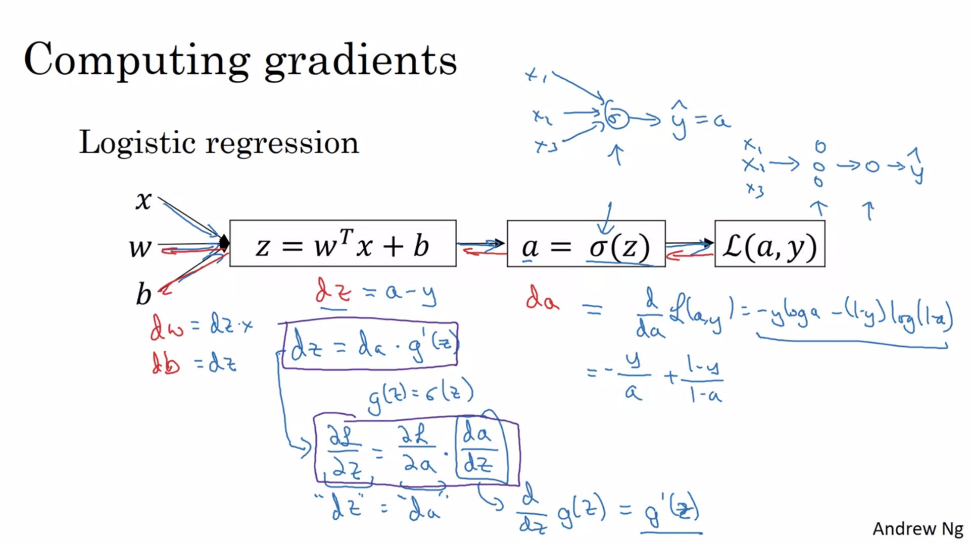

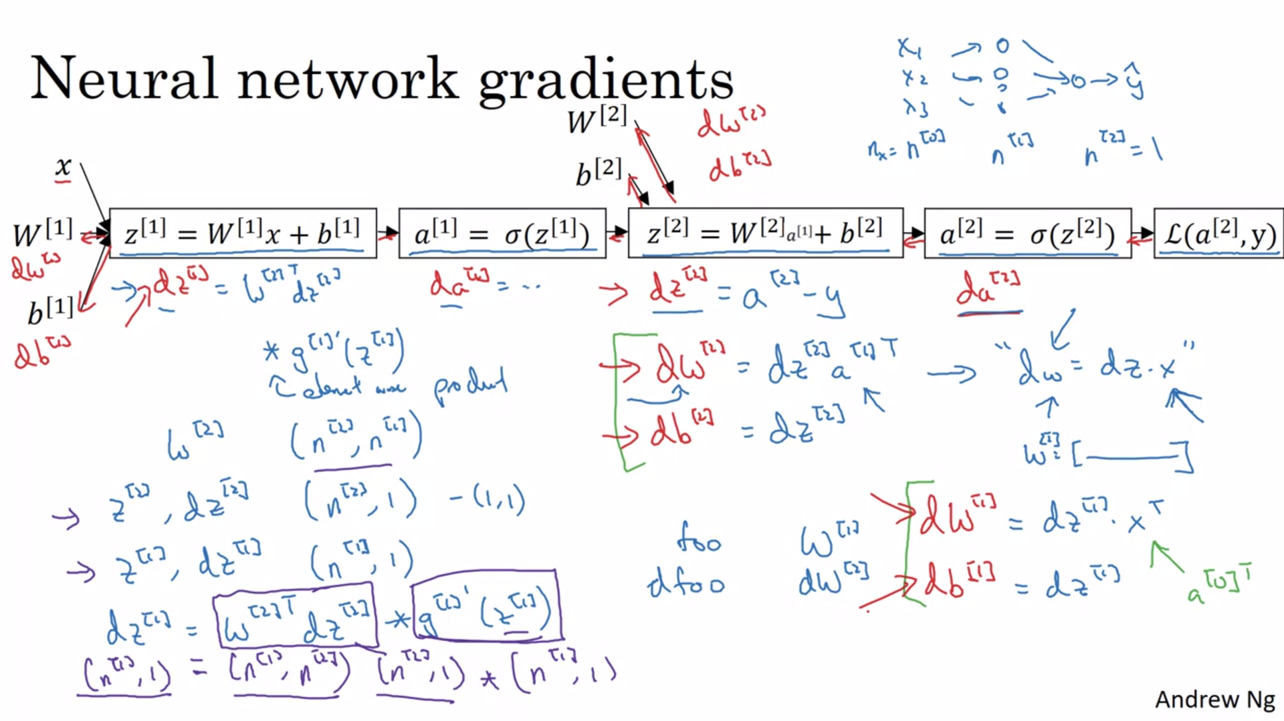

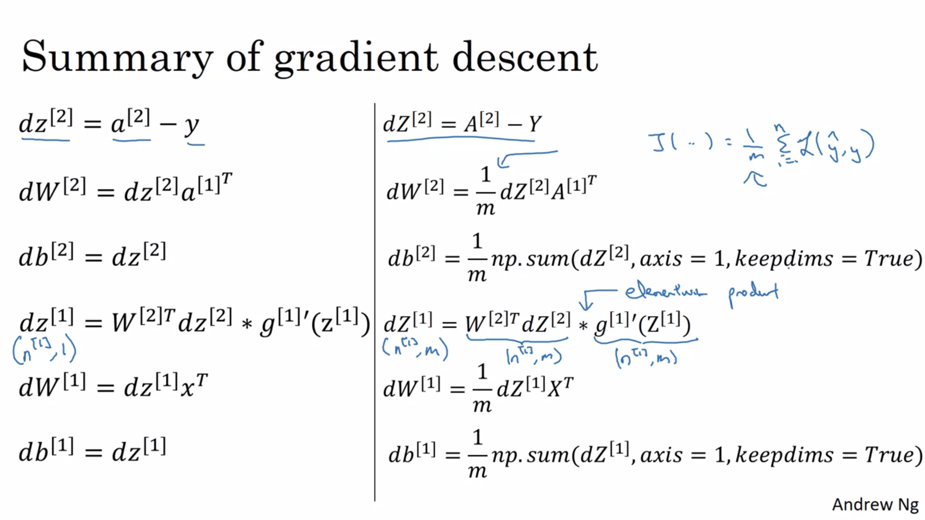

# Random Initialization

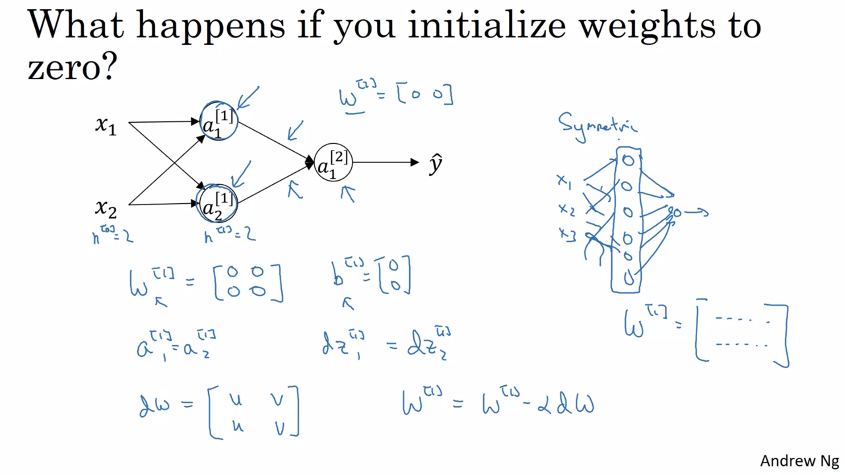

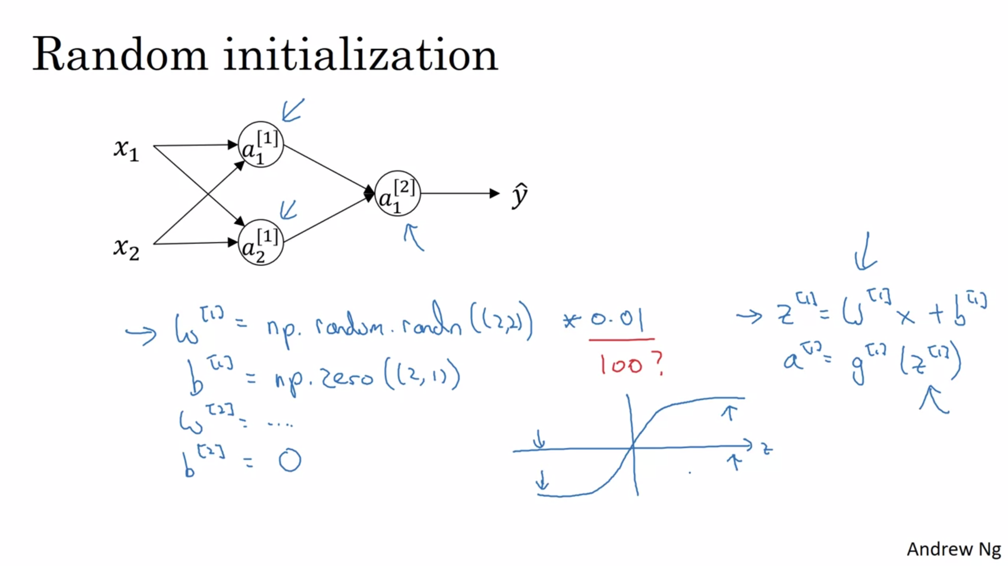

So you might be wondering, where did this constant come from and why is it 0.01?

Why not put the number 100 or 1000?

Turns out that we usually prefer to initialize

the weights to very small random values.

Because if you are using a tanh or sigmoid activation function, or

the other sigmoid, even just at the output layer.

If the weights are too large,

then when you compute the activation values,

remember that z[1]=w1 x + b.

And then a1 is the activation function applied to z1.

So if w is very big, z will be very, or at least some

values of z will be either very large or very small.

And so in that case, you're more likely to end up at these fat parts of the tanh

function or the sigmoid function, where the slope or the gradient is very small.

Meaning that gradient descent will be very slow.

So learning was very slow.

So just a recap, if w is too large, you're more likely to end up

even at the very start of training, with very large values of z.

Which causes your tanh or your sigmoid activation function to be saturated,

thus slowing down learning.

If you don't have any sigmoid or

tanh activation functions throughout your neural network, this is less of an issue.

But if you're doing binary classification, and your output unit is a sigmoid

function, then you just don't want the initial parameters to be too large.

So that's why multiplying by 0.01 would be something reasonable to try, or

any other small number.

And same for w2, right?

This can be random.random.

I guess this would be 1 by 2 in this example, times 0.01.

Missing an s there.

So finally, it turns out that sometimes they can be better constants than 0.01.

When you're training a neural network with just one hidden layer,

it is a relatively shallow neural network, without too many hidden layers.

Set it to 0.01 will probably work okay.

But when you're training a very very deep neural network,

then you might want to pick a different constant than 0.01.

And in next week's material, we'll talk a little bit about how and

when you might want to choose a different constant than 0.01.

But either way, it will usually end up being a relatively small number.

So that's it for this week's videos.

You now know how to set up a neural network of a hidden layer,

initialize the parameters, make predictions using.

As well as compute derivatives and implement gradient descent,

using backprop.

So that, you should be able to do the quizzes,

as well as this week's programming exercises.

Best of luck with that.

I hope you have fun with the problem exercise, and

look forward to seeing you in the week four materials.